Smart Medication Management System

Authors: Mariia Syz (S00291124@atu.ie), Oleksandr Babak (S00286477@atu.ie), Volodymyr Paliei (S00290281@atu.ie), Nazar Luhovyi (S00286478@atu.ie)

Trello Page : https://trello.com/invite/b/69a5da271ca56a0e2a509179/ATTI14b8d8a7dbeeaa8be0184e201120e2c3A593660F/моя-дошка-trello

GitHub Team Page :
https://github.com/Fury3322/Internet-of-Things-Group-Project

Links to any data gathered or data analysis planned:

Academic Research Articles
A Systematic Review on Pill and Medication Dispensers from a Human-Centered Perspective (https://link.springer.com/article/10.1007/s41666-024-00161-w)
Key Features of Smart Medication Adherence Products: Updated Scoping Review (https://aging.jmir.org/2023/1/e50990)
An IoT-Based Pill Management System for Elderly (https://www.informatica.si/index.php/informatica/article/view/4195)
Similar Arduino Projects and Inspiration Sources
https://projecthub.arduino.cc/ashraf_minhaj/meduino-smart-automatic-medicine-reminder-12ffd4
https://projecthub.arduino.cc/mirandadrummond/the-pill-dispenser-10-abc990
https://www.instructables.com/Create-an-Internet-Connected-Pill-Dispenser

Table of Contents:
The Problem 3
Summary of the Project Solution 5
Initial Design 6
Description of Data Generated 8
Medication Schedule Data 9
Alert Data 10
User Interaction Data 11
Data Usage 12
Code samples 13
Testing Plan 13
Hardware Testing 13
System Integration Testing 14
Diagram 14
Testing approach 14
Security analysi 15
Future improvements planned and potential next steps in developing the idea further 16

The Problem

In modern healthcare many individuals are required to take medication regularly in order to treat or manage medical conditions. This is particularly common among elderly individuals, patients with chronic illnesses, and people experiencing memory-related difficulties. Following a correct medication schedule is essential for effective treatment, as even small deviations from the prescribed schedule may reduce treatment effectiveness.

However, research shows that a large proportion of patients fail to follow their medication schedule correctly. According to the World Health Organization, approximately 50% of patients with chronic illnesses do not take their medication as prescribed. This phenomenon is known as medication non-adherence and it can result in serious health consequences including worsening medical conditions, complications and increased hospitalisation rates (Sabate, 2003).

There are several reasons for this problem. One of the main factors is simple human error. People often forget to take medication because of busy schedules, stress, fatigue or memory problems. This issue becomes even more significant for elderly people who may need to take multiple medications at different times during the day.

Another challenge is the organisation of medication. Patients may accidentally mix different pills, forget whether they have already taken their medication, or lose tablets entirely. Traditional pill organisers help separate medication but they do not provide reminders or tracking systems.

Technological solutions have been developed to address this issue. For example, the Meduino Smart Automatic Medicine Reminder project demonstrates how Arduino technology can be used to create a medication reminder system. Another project, The Pill Dispenser, focuses on organising medication while providing reminder alerts. More advanced systems such as the Internet Connected Pill Dispenser allow medication usage to be monitored remotely via internet connectivity.

Despite these developments, many of the existing solutions are either expensive, complex or difficult to install and operate. For elderly individuals or people with limited technical experience, these systems may not be practical. Therefore, there is a clear need for a simple, affordable and user-friendly system that helps people remember to take their medication while also providing a way to track medication intake.

Summary of the Project Solution

The proposed solution is a smart pill container based on Arduino technology that combines medication organisation, reminder alerts and medication tracking functionality.

The device is built using a pill container with multiple compartments used to store different medications or doses scheduled for different times of the day. This structure allows medication to be organised clearly and reduces the risk of confusion between pills. At the centre of the container an electronic module is installed which includes an Arduino microcontroller, LCD display, confirmation button, LED indicator and buzzer.

The Arduino microcontroller manages the timing system and activates reminders when medication needs to be taken. When the scheduled time arrives, the device automatically triggers a reminder signal. This reminder may include a sound alert, LED light signal or a combination of both. Using multiple notification methods increases the effectiveness of the system, ensuring that the user notices the alert even in noisy environments or if they have reduced vision.

At the same time, the display provides a clear message indicating which compartment should be opened or which medication should be taken. This reduces confusion and helps users follow their medication schedule correctly.

After taking the medication, the user presses a confirmation button on the device. This action records that the medication has been taken successfully. If the confirmation button is not pressed within a certain time, the system can repeat the reminder to ensure the medication is not missed.
One of the most important features of the proposed system is the potential future integration with mobile devices. Medication events could be automatically recorded in a mobile application or monitoring system. This would allow users, family members or caregivers to track medication adherence and receive notifications if a dose is missed.

Another major advantage of the design is simplicity and accessibility. The system is designed to be easy to understand and operate, particularly for elderly users. Large buttons, a clear display and simple visual indicators ensure the device is intuitive and easy to use.

Compared with existing systems, the proposed solution offers several advantages:

• simple and user-friendly design
• low cost due to Arduino components
• combination of pill organisation and reminder system
• potential for mobile tracking and monitoring
• scalable design that can be expanded with additional features

Overall, this project aims to provide a practical, affordable and accessible solution that improves medication adherence and supports better health management for users.

Initial Design
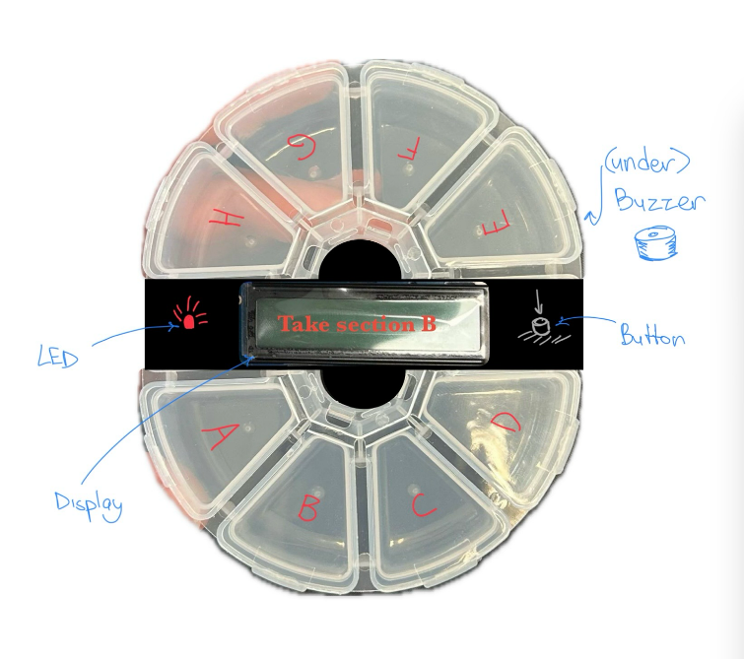
Device Sketch - Initial concept of the smart pill reminder container with LED, buzzer, display and confirmation button
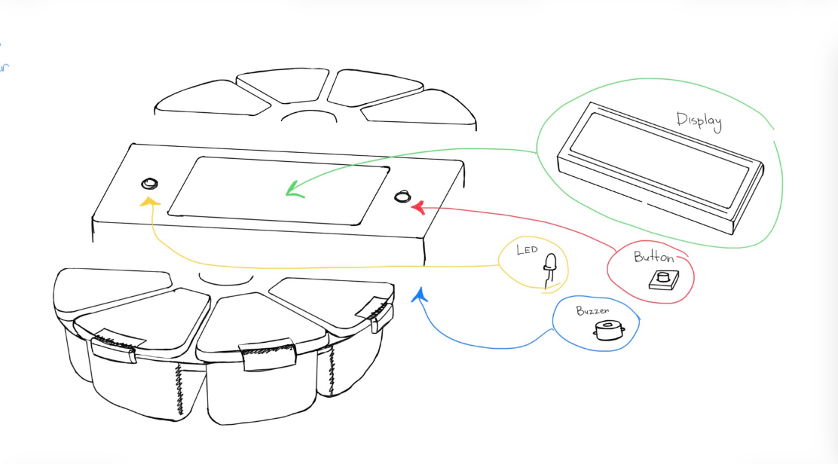

Hardware Setup - Arduino microcontroller connected to LCD display, LED indicator, buzzer and push button
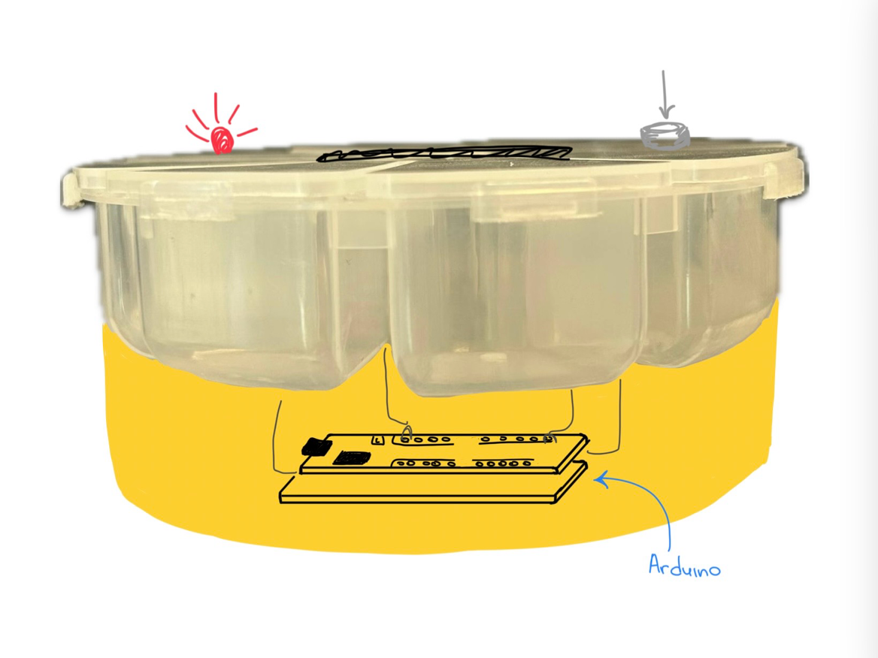
Code Design - Timer-based system that activates alerts and displays medication instructions
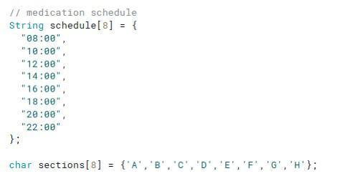
This part of code is responsible for declaring the array variable that manages the medication schedule. And assigning each section its own letter.
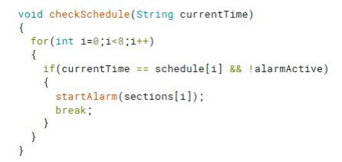
A method that checks the schedule compares the current time and triggers an alarm if the medication time and the current time match.
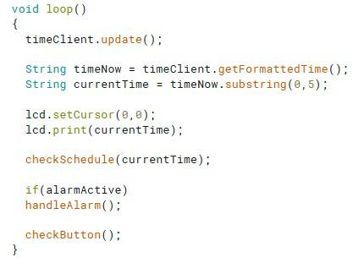
This screenshot shows a cycle that checks the current time and checks the schedule.

Description of Data Generated
The Smart Pill Reminder system generates several types of operational data while running. This data is used to control the medication reminder process and interact with the user through visual and audio notifications.
The system uses an Arduino microcontroller connected to a WiFi network to obtain the correct time from an internet time server. Based on this time, the system checks whether it is time for the user to take medication.
Time Data
The system retrieves real-time clock data using the Network Time Protocol (NTP). This allows the device to always know the current time without requiring manual configuration.
The Arduino receives time data from an NTP server and converts it into a readable format.
Example generated time data:
Current Time: 08:00
Current Time: 14:00
Current Time: 20:00
This time data is continuously updated and displayed on the LCD screen.

Medication Schedule Data
The system stores a predefined medication schedule inside the program. The schedule consists of multiple reminder times throughout the day.
Example schedule used in the system:
08:00
10:00
12:00
14:00
16:00
18:00
20:00
22:00
Each scheduled time corresponds to a specific medication compartment labeled A–H in the pill container.
When the current time matches one of these scheduled times, the system generates a reminder event.

Alert Data
When a reminder is triggered, the system generates alert data that activates several hardware components.
These include:
• LED indicator turning on
• Buzzer sound alert
• Message displayed on the LCD screen
Example alert message displayed on the LCD screen:
Take Section B
This alert informs the user which medication compartment should be opened.
The buzzer produces an audible signal every minute until the user confirms the reminder.

User Interaction Data
The system also generates input data when the user presses the confirmation button.
When the button is pressed, the Arduino registers the event and stops the alarm. The LED turns off and the buzzer stops sounding.
Example user interaction event:
Button Pressed – Medication Confirmed
The LCD screen then displays a confirmation message:
Medication Taken
This ensures that the user acknowledges the reminder.

System Status Data
The system also tracks internal operational states during execution. These states help manage reminders and alerts.
Examples of system state data include:
AlarmActive = true / false
CurrentSection = A, B, C, D, etc.
ReminderStatus = Active or Completed
These values are temporarily stored in the Arduino memory while the device is running.

Data Usage
All generated data is used by the system to:
• track the current time
• determine when medication reminders should occur
• activate visual and audio alerts
• confirm when medication has been taken
The data is processed in real time by the Arduino and does not require permanent storage.
Equipment Required
The following components are used to build the system.
Component | Purpose
Arduino Uno | Main controller
LCD 16x2 Display | Displays instructions
LED | Visual reminder
Buzzer | Sound alert
Push Button | User interaction
Pill Container | Physical medication storage

Code samples
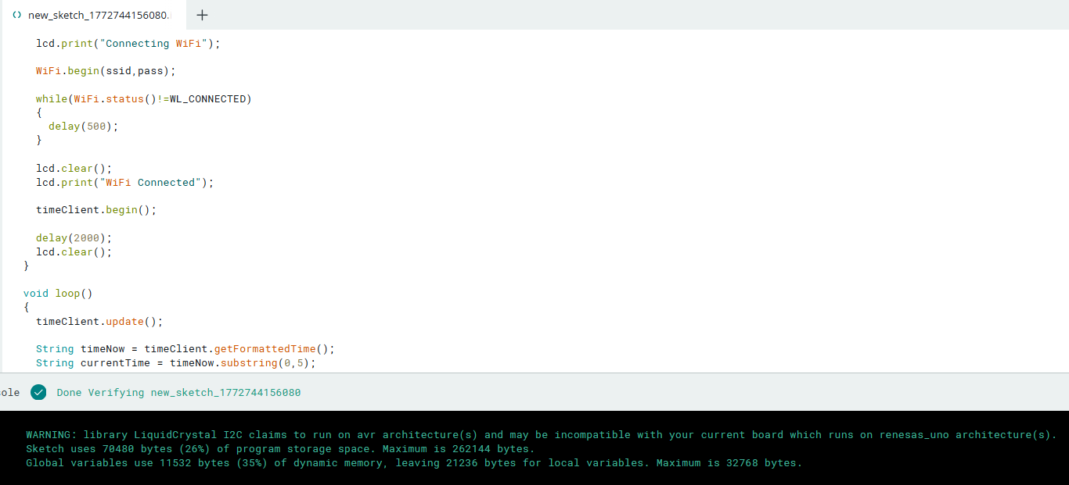
Verified test sketch
Parts List
Part | Quantity
Arduino Uno | 1
LCD Display (16x2) | 1
LED | 1
Buzzer | 1
Push Button | 1
Pill Container | 1

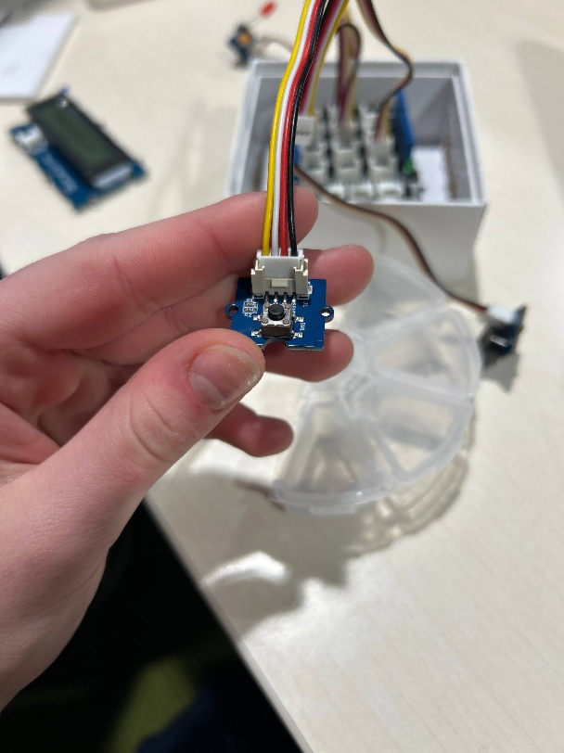

Testing Plan
Several tests were conducted to verify system functionality.

Hardware Testing
Each component was tested individually:
• LED activation
• Buzzer sound output
• Button response
• LCD message display

System Integration Testing
All components were connected to the Arduino board to verify that the reminder system worked correctly.

Diagram
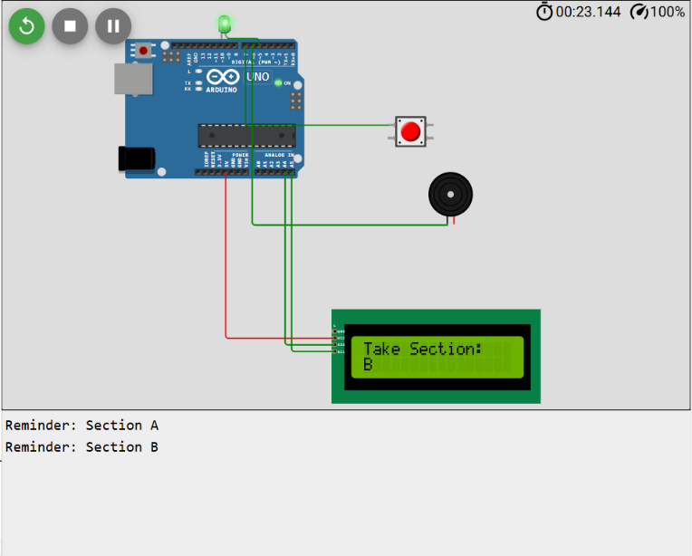
The system successfully:
• Displayed medication instructions
• Activated LED and buzzer alerts
• Allowed the user to stop alerts with the button

Testing approach
To ensure the Smart Pill Organizer works reliably, both software testing and hardware testing were planned. The goal of testing was to verify that each component of the system functions correctly and that all components work together as expected.
The testing process was divided into three stages:
Unit Testing – testing individual components separately
Integration Testing – testing how hardware and software work together
System Testing – testing the full functionality of the device
Testing was performed using both the Arduino IDE and the Wokwi simulator, allowing the system to be validated before physical hardware implementation.

Security analysi
The Smart Pill Box system uses an Arduino microcontroller, WiFi connection, LCD display, buzzer, and button to remind users to take medication at scheduled times. Because the system connects to a network and relies on time synchronization, several potential security vulnerabilities must be considered. One possible risk is unauthorized access to the WiFi connection. If the WiFi credentials are exposed in the source code, an attacker could connect to the network or manipulate the device.
To prevent this, WiFi credentials should be stored securely and not shared publicly, and a secure network with strong passwords should be used. Another potential vulnerability is time manipulation through the Network Time Protocol (NTP). Since the system retrieves time from an internet server, an attacker could theoretically spoof the NTP server and send incorrect time data, causing the medication reminders to trigger at the wrong time. This risk can be reduced by using trusted NTP servers and validating time updates before applying them to the system.
Physical security is also important. Because the device includes a button that stops the alarm, someone could press the button without actually taking the medication. To reduce this risk, the system could log when alarms are dismissed or require additional confirmation. Furthermore, protecting the Arduino and wiring inside a closed enclosure prevents tampering with components such as the buzzer or LED.
Finally, secure coding practices should be followed to prevent software errors that may create vulnerabilities. This includes validating inputs, avoiding unnecessary network exposure, and regularly updating libraries used for WiFi and time synchronization. By implementing these protections, the Smart Pill Box system becomes more reliable and resistant to both digital and physical security threats.

Future improvements planned and potential next steps in developing the idea further
In the future, the project could be expanded by connecting the device to Arduino IoT Cloud, allowing medication data to be stored and monitored through a cloud-based system. This would enable the device to record medication intake events and provide a history of when medication was taken. Based on this collected data, the system could also generate automatic medication adherence reports, showing when medication was taken, when doses were missed and the overall adherence to the medication schedule. These reports could be useful for doctors and healthcare professionals to monitor patient progress and adjust treatment if necessary.
Another potential improvement is the addition of mobile phone notifications. If the user does not confirm medication intake within a certain time, the system could automatically send a notification. These notifications could be sent either to the user or to a caregiver, family member or healthcare assistant who is responsible for monitoring the person’s medication routine.
This feature would be particularly useful for elderly individuals or people with memory-related conditions, as it allows another person to monitor whether medication has been taken on time and provide support if necessary.
Overall, these improvements would transform the device from a simple reminder system into a connected healthcare monitoring tool, improving medication adherence and supporting both patients and healthcare providers.

